**Final Project Proposal: Bitcoin Dashboard**

Heather Dietrich

**Topic:**

This dashboard will track the Bitcoin based on:

* Volume (daily data)
* Price (daily data)
* market cap (daily data)
* News
* Google search interest

Facebook Prophet will be applied to forecast the future price of Bitcoin and provide additional insight into trends on price (ie. Best days of the week to buy vs. sell)

**Data:**

* New York Times API
* Alpha Vantage API
* Google trends

**Engineering:**

* Google colab will be used for ETL and Facebook Prophet
* Postgresql database hosted by AWS
* Flask app hosted on Huruko

**Visual Proposal:**

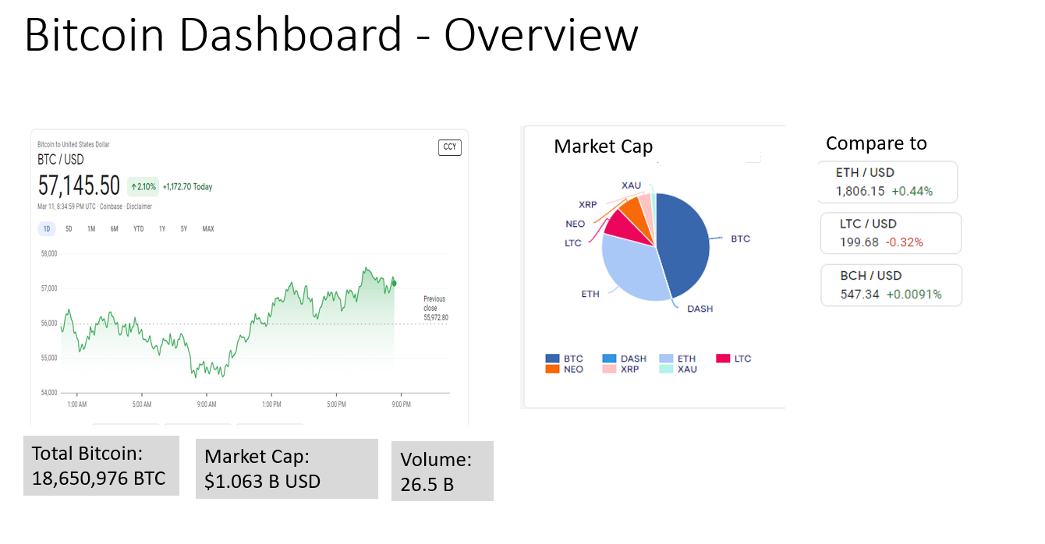

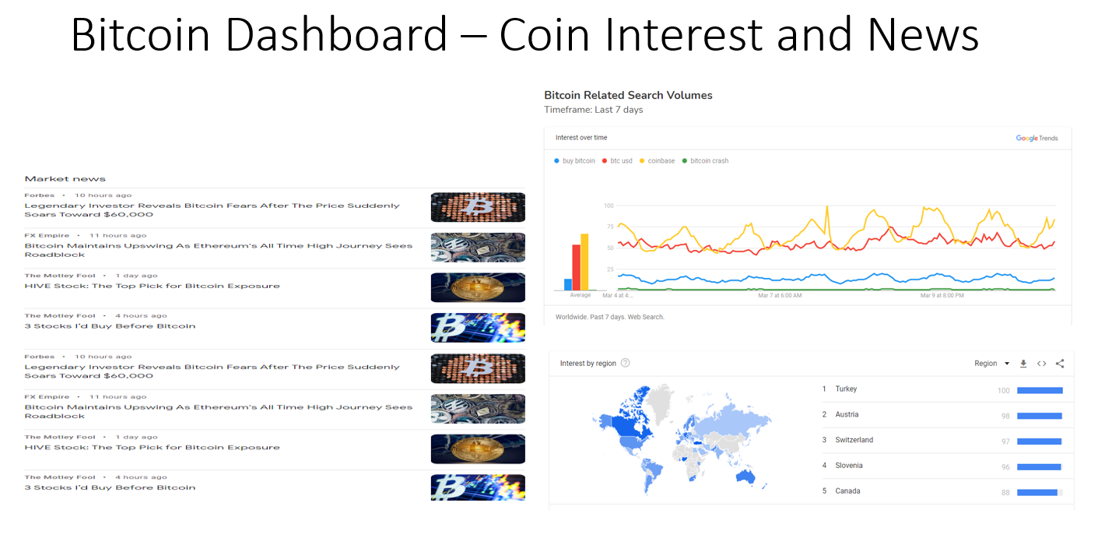

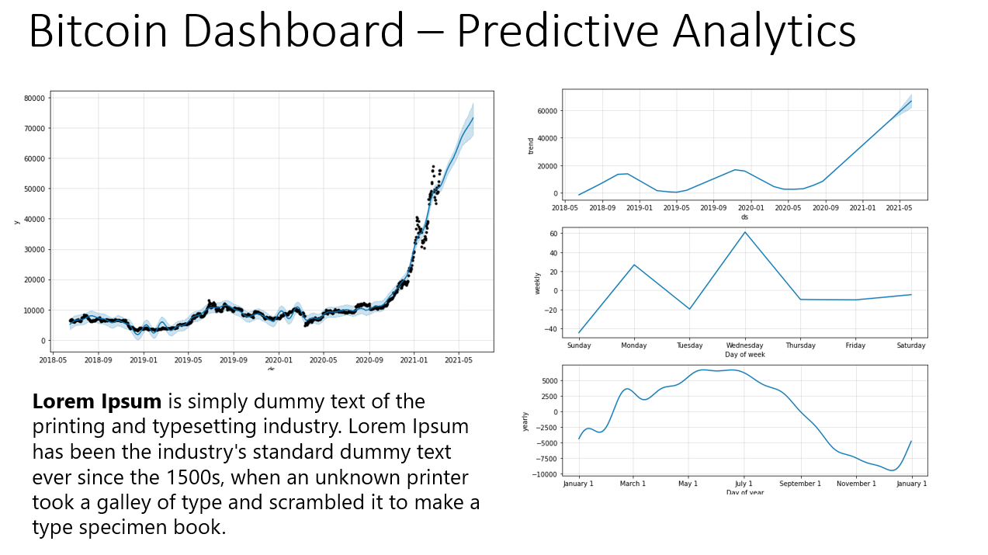

**Dashboard Style:**

